ALIGNING INVENTORY WITH DEMANDS TRENDS- FRESH CART

Client: FreshCart

Role: Data Analyst

Name: Ajayi Moses

Tools Used: SQL, Microsoft Excel, Power BI, Pivot Tables, Logical Functions, Charts

**Dashboard**

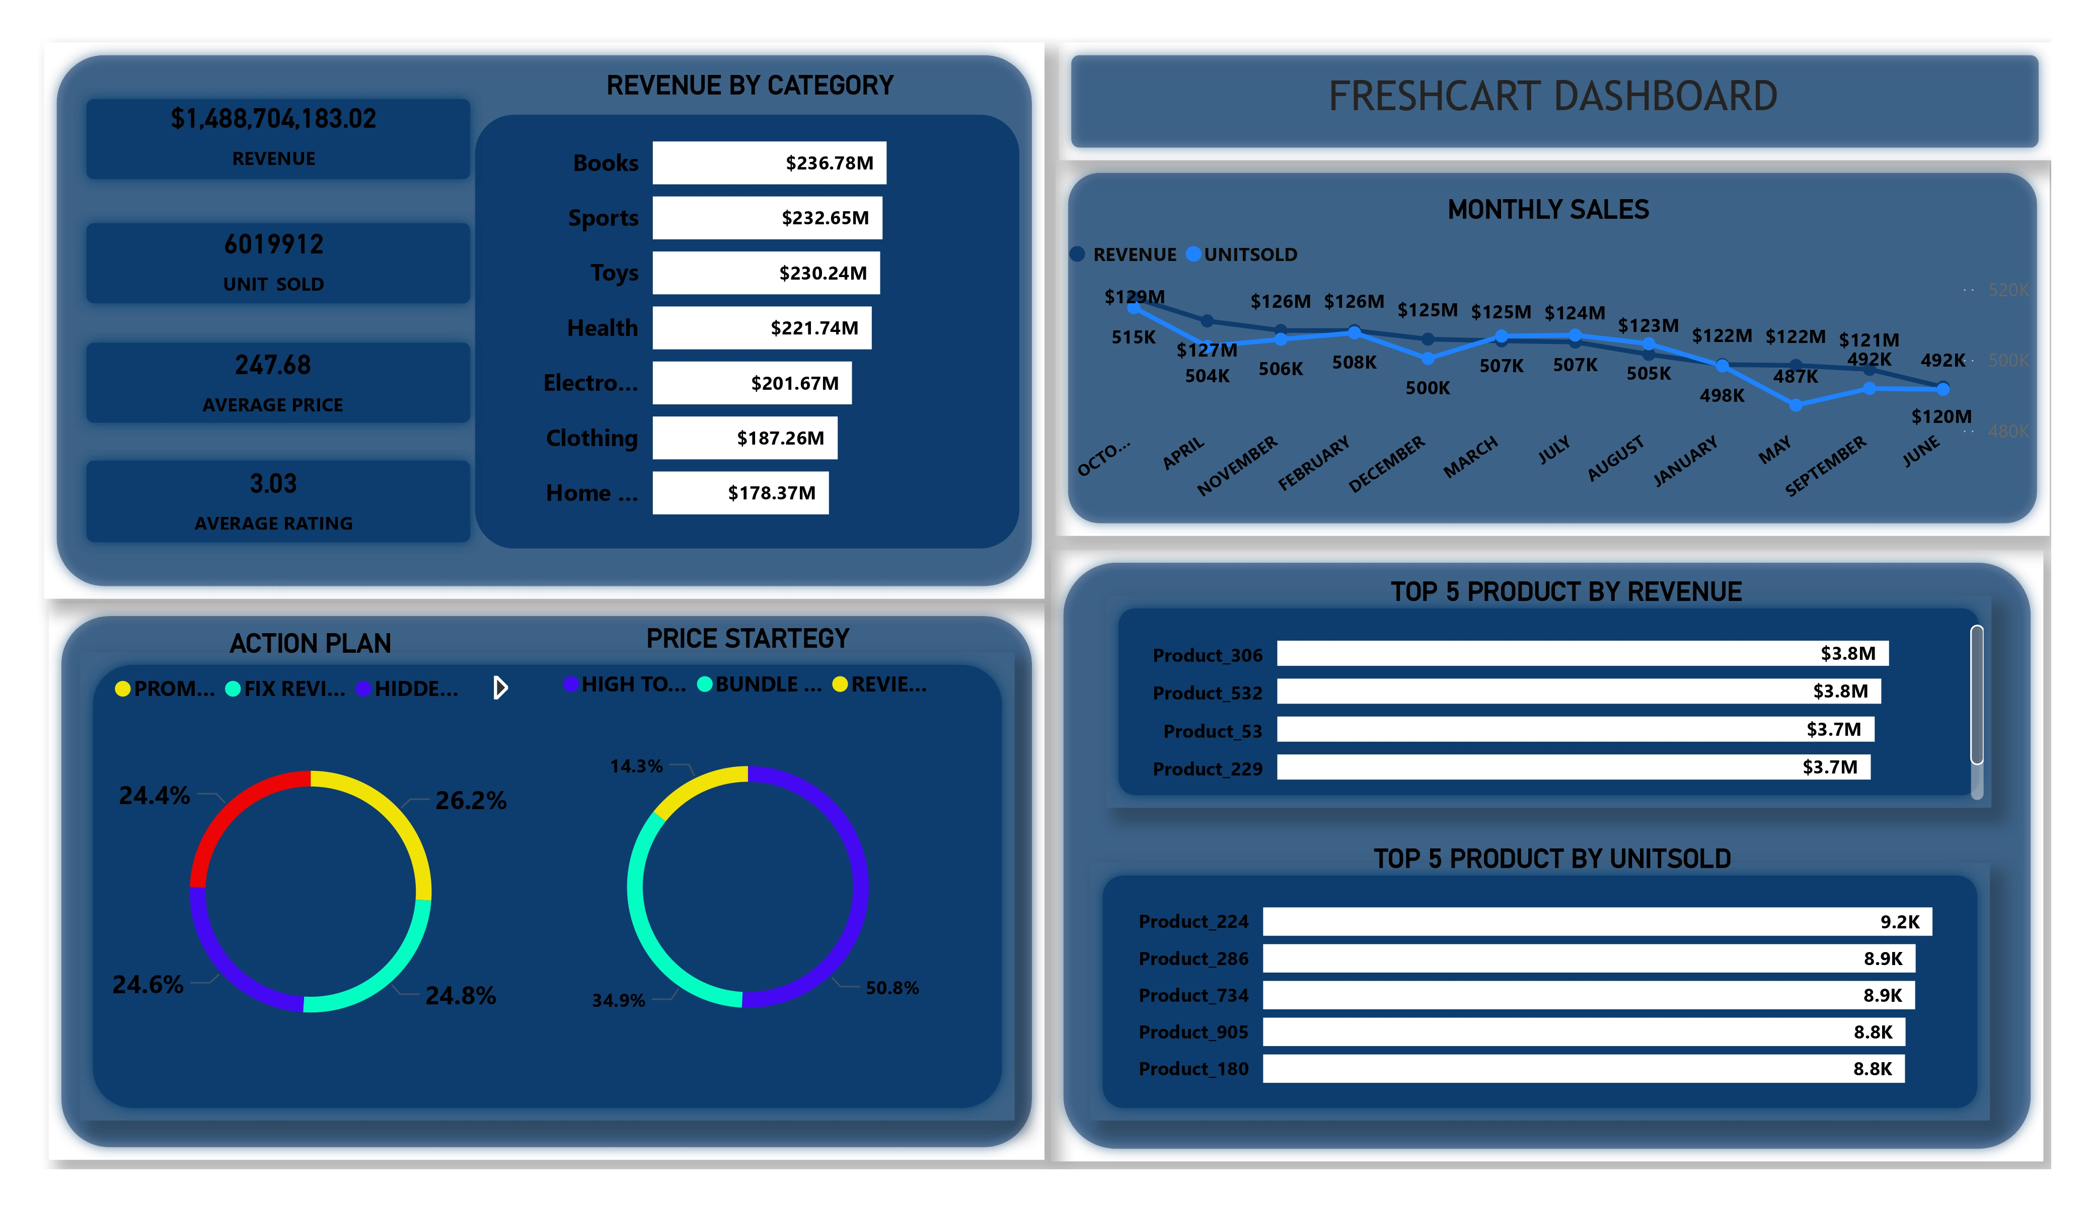

# 🧠 Background

FreshCart, a fast-growing Nigerian e Commerce company with over 100 consumer goods, faced challenges in managing stock levels, allocating marketing budgets, and setting effective prices. Despite solid sales, there was a mismatch between inventory, customer reviews, and promotional effort—requiring a data-driven strategy.

# ❓ Problem Statement

"How can FreshCart intelligently segment its products based on sales, reviews, and revenue performance to optimize marketing spend, refine pricing strategies, and uncover hidden growth opportunities — while minimizing inventory and promotional waste?"

# 🎯 Objectives

- Segment products by performance

- Target marketing more effectively

- Identify undervalued high-rated products

- Recommend price adjustments and bundling strategies

- Align inventory with demand trends

# 🛠️ Methodology

## Data Preparation

Imported dateset with Product_id, Product Name, Category, Quantity, Price, Review Score,review_count,sales_month_1………12  
Created helper columns  
- Revenue: =[@Price]*[@Quantity],strategy, price_strategy.

## Pivot Table Analysis

Built a pivot summarizing Total Sales, Average Review, and Total Revenue per product.  
Added helper columns for segmentation and revenue categories.

## Segmentation Logic

Marketing Segments:  
• Promote More – High Sales & High Review  
• Hidden Gem – Low Sales & High Review  
• Fix Quality – High Sales & Low Review  
• Avoid Marketing– Low Sales & Low Review

**Revenue Opportunities:**  
• High Price Tolerance – High Revenue at High Price  
• Discount Candidate – Low Revenue at High Price  
• Bundle Opportunity – Moderate Revenue with Up-sell Potential

# 🔍 Key Findings

* 246 Hidden Gems: Highly rated but under-marketed products.
* 248 Quality Fixes: High-sellers with poor reviews—need improvement.
* 510 High-Tolerance product: High-priced items show strong price tolerance—prime for premium positioning.
* 244 At-Risk Items: Low-performing products flagged for discontinuation.

**EXPLORATORY DATA ANALYSIS**

Before we get to the point I think it is best if we all have a good understanding of the data. We have 1000 rows of data-set with 17 columns.

* Product_id : This is the identification number of the product
* Product_name : This is the name of the product
* Category : this is the category of product being sold
* Price : This is the amount of money the product is being sold
* Review_count : this is the number of times review was given to a particular product
* Rating :this is the review score given to a particular product
* Sales_month_1,……..,12 : this is the number on unit sold in each month

**Category analysis report**

Here is the report of the revenue per category, total unit sold per category, average price per category and the average review rating per category

**TOP 5 BEST SELLING PRODUCT**

Out of the 1000 product these are the top 5 best selling product by revenue

**TOP 5 BEST SELLING PRODUCT BY UNIT SOLD**

Out if the 1000 product this are the top 5 most sold product

# ✅ Recommendations

1. Reallocate marketing to Hidden Gems.  
   2. Launch quality improvement campaigns.  
   3. Bundle moderate performers with top-selling items.  
   4. Use sales trends to guide inventory.  
   5. Conduct price experiments on high-tolerance products.

# 📎 Visuals

**RAW DATA BEFORE CLEANING**

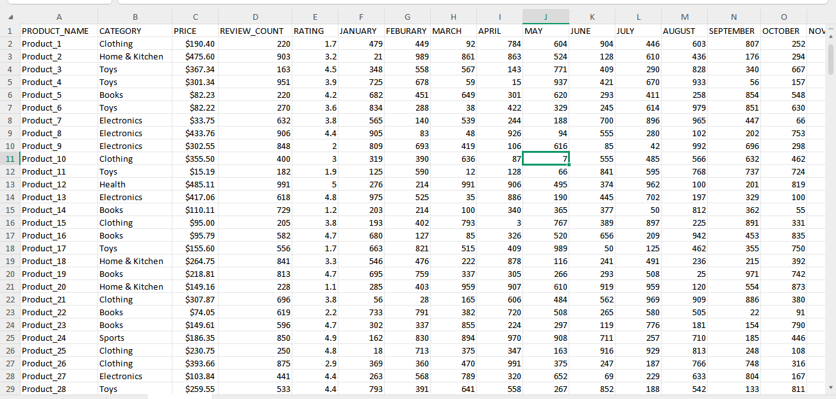

**DATASET AFTER CLAEANING 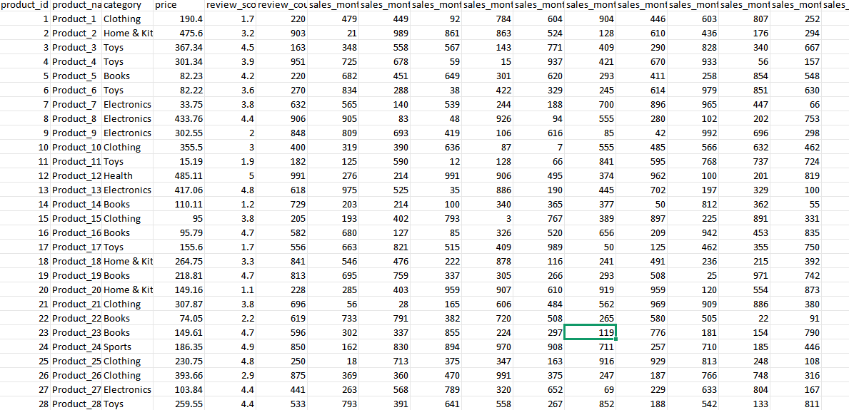Full dasboard**

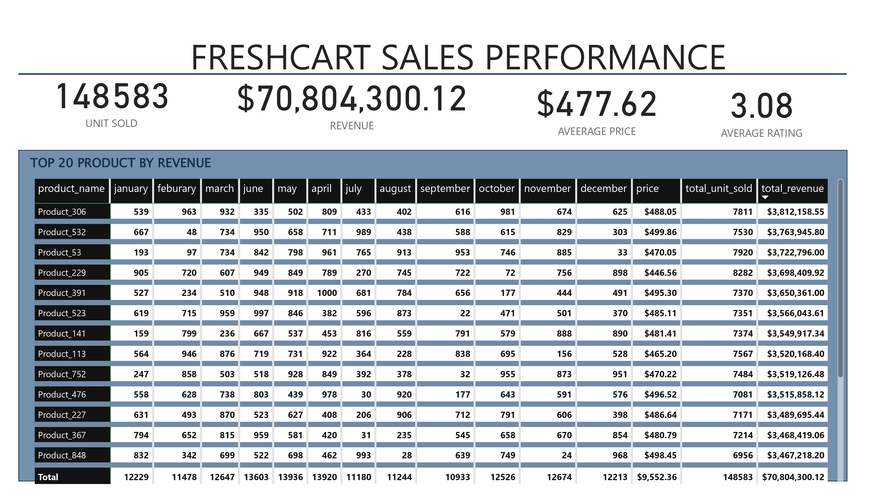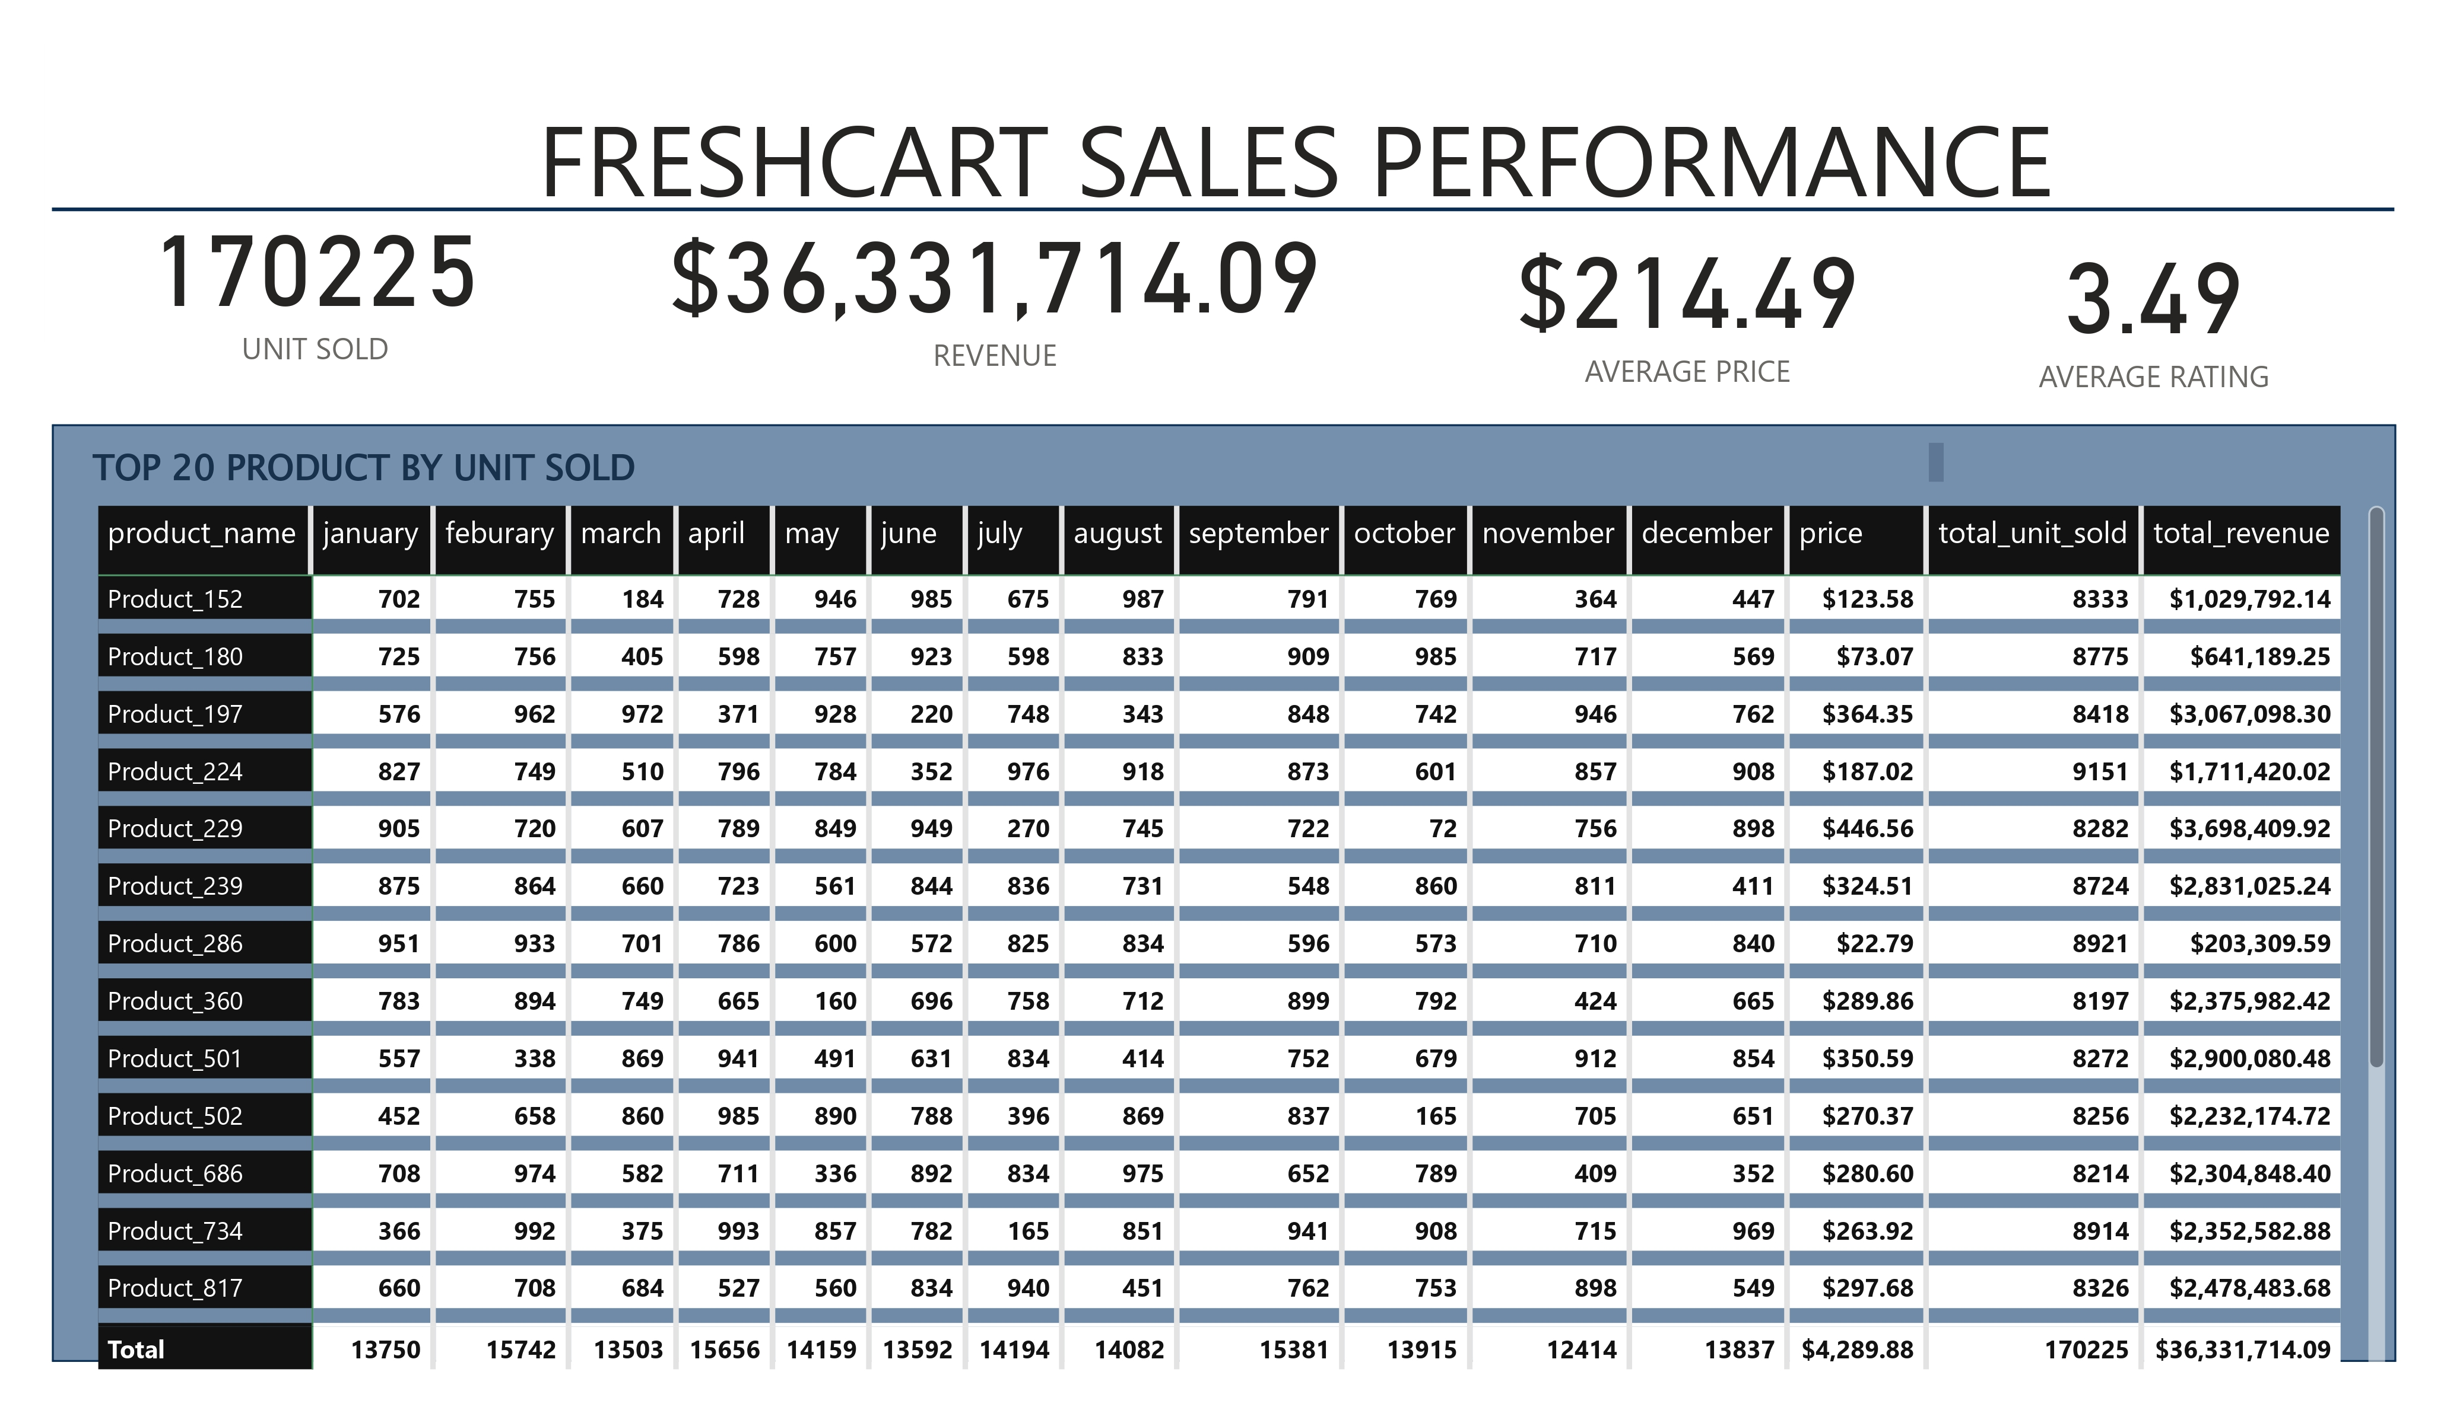

🧾 Conclusion

By applying Excel-based analytics and segmentation logic, FreshCart gained actionable insights to optimize marketing, pricing, and inventory—transforming data into business impact.